Using DDL statements to create a database with tables and relationships

1. Exercise 1

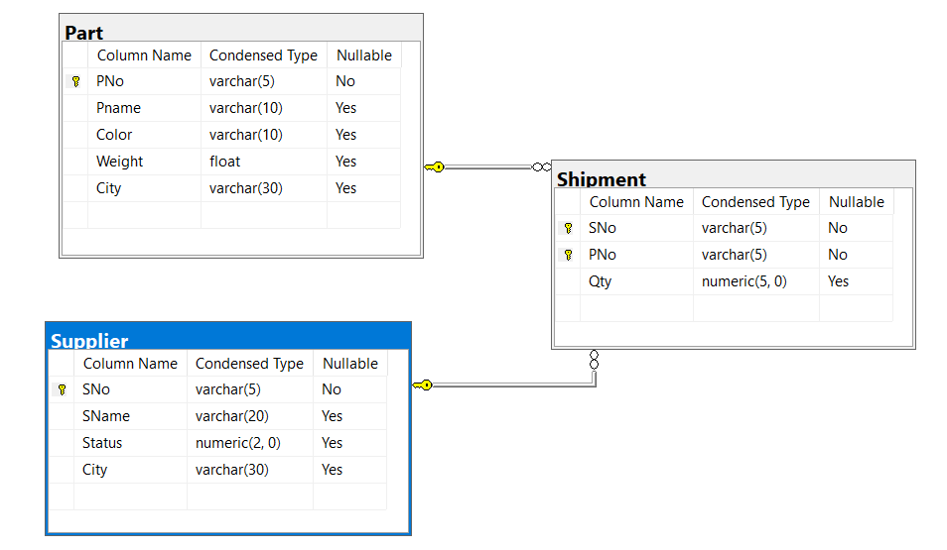

1. Exercise 2

